**Play Video at Random Position StreamerBot Extension**

**Created by Vengey**

**[** [**https://twitter.com/ItsVengey**](https://twitter.com/ItsVengey) **|** [**https://www.twitch.tv/itsvengey**](https://www.twitch.tv/itsvengey) **|** [**https://vengey.carrd.co/**](https://vengey.carrd.co/) **]**

**How to Import into StreamerBot…**

**STEP 1: *Copy this LONG string***



**STEP 2**: ***Click Import in Streamerbot***

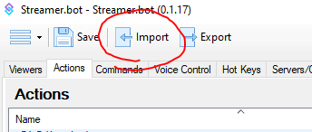

**STEP 3**: ***Paste the code into “Import String”, an action and command will show up, then hit “Import”***

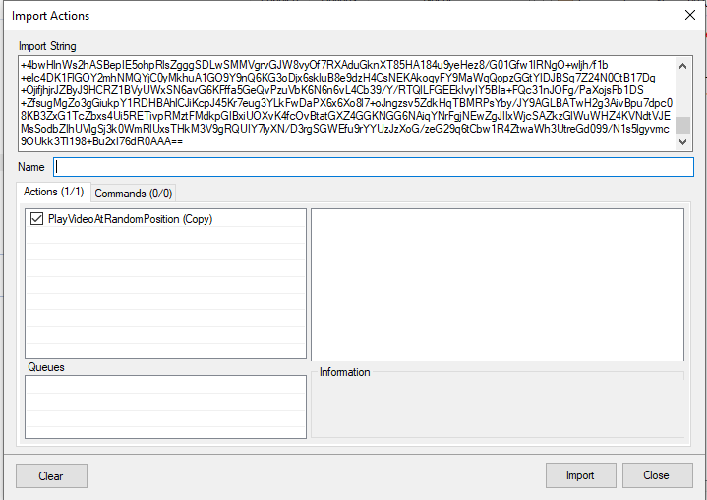

**STEP 4**: ***Go to your Actions tab; look for an action called “PlayVideoAtRandomPosition”***

Expand the section within the blue variable text, and adjust the SourceName variable to match exactly what your source is in OBS, and do the same with SceneName to match what your scene is in OBS where the source lives! Adjust the timing variable too to match how long your video is so it doesn’t end early!

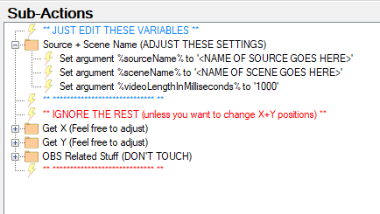

***And that’s it! Wire this action up to a channel point or a command, rename the action itself to fit whatever you’d like it to be, and any time you have another video you want to do this with just duplicate the action and change the variables, easy as that!!!!***